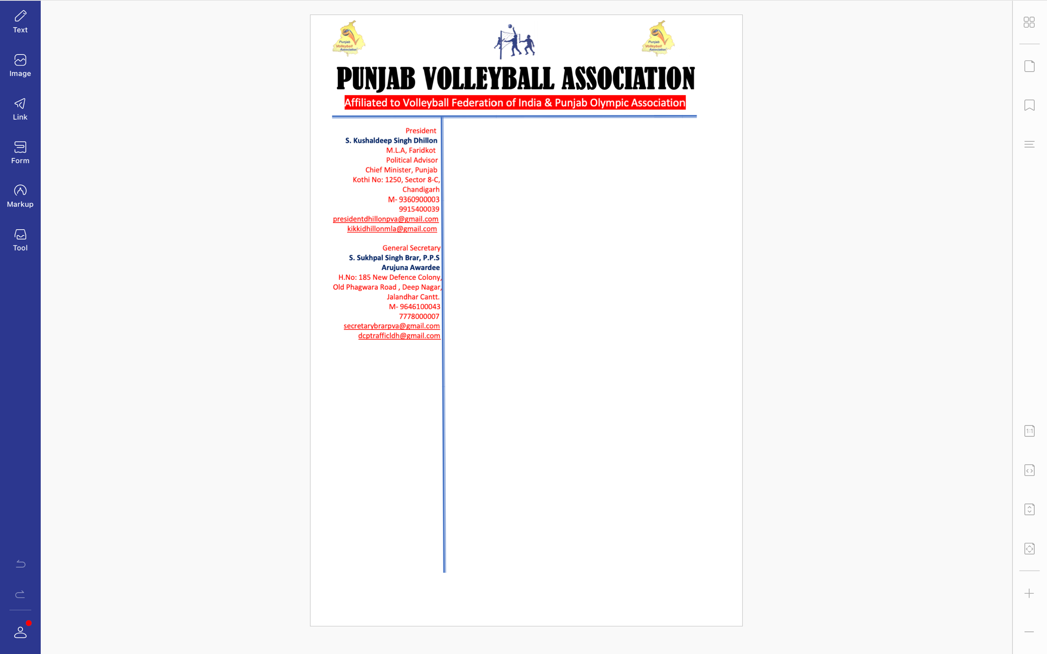



**Ref. PVA/BRAR/2022/Spl.-(2)/0222** Dated: 02-08-2022

v`l:

fwierYktr sports pMjwb

cMfIgVH

ivSw: nYSnl gymz swl 2022-23 dy kYNp qy hox vwly Krcy sbMDI

auprokq ivSy dy sbMD iv`c Awp jI dy p`qr nMbr sports-ss1-fI.ey4-2022/7804-26 imqI 28-07-2022 dy sbMD iv`c Awp jI nUM bynqI krdy hW ik gujrwq ivKy hox vwlIAW nYSnl gymz swl 2022-23 leI 21 (ie`kI idn) idnW dy kYNp lwaux dI AwigAw id`qI jwvy jI[ ies sbMDI aukq kYNp qy hox vwly Krcy leI AgvweI vI id`qI jwvy jI[

DMnvwd sihq

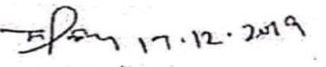

suKpwl isMG brwV, Arujnw AvwrfI

jnrl sk`qr

pMjwb vwlIbwl AYsoSIeySn